Tony Evers, Governor
Preston D. Cole, Secretary
Telephone 608-266-2621
Toll Free 1-888-936-7463
TTY Access via relay - 711

State of Wisconsin
DEPARTMENT OF NATURAL RESOURCES
Kettle Moraine State Forest - Northern Unit
N1765 County Road G
Campbellsport WI 53010
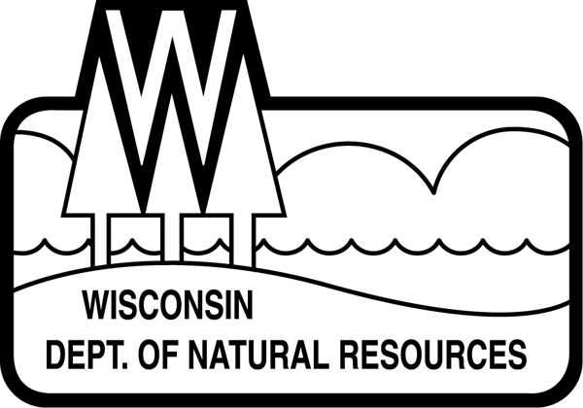
September 22, 2022

EVENT ANNOUNCEMENT

Fall Fest

Come out for a day of a family fun at the second annual Fall Fest! The Fest will be held from 3:00 to 8:00 p.m. at the Mauthe Lake Recreation Area of the Kettle Moraine State Forest - Northern Unit, which is located at N1490 County Road GGG, Campbellsport (south of County Road SS near New Prospect). A Wisconsin State Park System vehicle admission sticker is required.
Throughout the event create clever crafts, play fun-filled games, meet Smokey Bear, and warm up a roaring fire. From 3:00-6:00 check out all the cool equipment the Dept. of Natural Resources wardens and rangers use as well as ask your questions about what they as part of their jobs. At the same time, you can carve your own pumpkin to take home. At 5:30 p.m. judges will award prizes for the cleverest pumpkin carving and the one that best meets the theme of the forest menagerie.
Dress in you best costume to enter the costume contest at 6:00 p.m. You may win a prize for the finest forest animal or the cutest.
Follow the trail between 4:00 and 8:00 p.m. to meet a menagerie of forest animals to learn a bit about their unique adaptations for survival. After dark the trail will be illuminated for an exciting walk through the autumn woods.
Paddygrass will entertain the crowds with their unique celtic influenced music from 3:30-5:30. Form 6:30-7:30 join the campfire sing-along with Chris Lilek.
Satisfy your hunger by purchasing a tasty meal from Hot Dishes food truck or a snack from the 3 Sweets Bakery and Café concession stand. The Friends of the Kettle Moraine will be selling hot and cold apple cider, fall-themed bakery, and caramel apple sundaes as a fund raiser for a new kayak launch and Tamarack Trail upgrades.
Join us for a marvelous day of fun educational entertainment for all ages! For more information, call the Ice Age Visitor Center staff at (920) 533-8322. The center is open Wednesday through Friday from 8:30 a.m. to 3:30 p.m. and on Saturday and Sunday from 9:30 am to 4:30 p.m.
# # #

