We welcome you back to enjoy our
Fall Soup Supper

Chili & variety of soups
bread, crackers, dessert & beverage
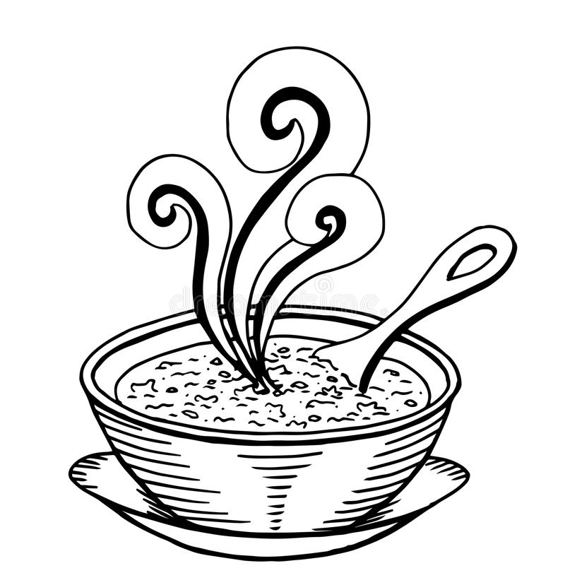
$8.00 - adults
$4:00 children ages 4 thru 10

Sunday, October 23rd
4:00 – 6:30 p.m.

Salem-Eldorado UMC
*****Enjoy our new entrance and ride the lift to the lower level *****

W7910 Church Rd. - Corner of Hwy I and Church Rd.
in the township of Eldorado

